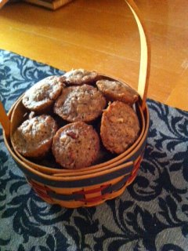
Pecan Praline Muffins

New Orleans was my first weekend tour I produced for my tour company. In 2012 we will be bringing back the “Big Easy”
Only a few months after Hurricane Katrina and the first class that the Cookn’ Cajun Cooking School held, they made terrific mini muffins. Here is my version. If you are interested in the spring 2012 tour for the New Orleans area please email me at ggeary@aol.com to go on the list.

Equipment:
Mini-muffin pans (24)
Measuring cups
Rubber spatula
Large bowl
#40 disher

Yield: 24 mini-muffins (You cannot make this into larger sized muffins they will not work)

1 cup packed brown sugar
1 cup pecans, toasted and finely chopped
1/2 cup all-purpose flour
1 tsp ground cinnamon
2/3 cup unsalted butter, melted and cooled
2 large eggs, beaten

1. Preheat oven to 350°F and place rack into the center of the oven. Spray the muffin pan cavities with a non-stick spray that has flour in it, (This is very important or they will stick)

2. In a large bowl, combine brown sugar, pecans, flour and cinnamon. Add melted butter and eggs. Mix to only incorporate. Set aside for 10 minutes.

3. Using a #40 scoop, divide batter into the 24 tins. Bake for 18-20 minutes or until light brown and crunchy looking. Let cool 10 minutes in tin prior to removal.

Variation: If using for a brunch, make a swirl of Cream Cheese Icing on top for a sweet creamy taste.
Important Tip: These will only work in small mini-muffin tins. Also, they have to be sprayed with a flour-based non-stick spray.

